# Presidential Initiative for Artificial Intelligence and Computing (PIAIC)

**PIAIC Batch 4-35 IoT**

https://www.piaic.org

Internet of Things (IoT) Specialist Program

Quarter 2: Rust Programming

**Assignment # 3**

1. Run The following code and Explain the output in your wordings:
2. fn main(){

Let r ;

{

Let x = 5;

r=&x;

}

println!(“{}”,r);

}

**ANSWER:**

It’ll give an error, because r is borrowing the x value and the scope of x is dropped before r is used.

1. Write a rust program:
   1. Define a struct Students with attributes (name , age , education, timing) all attributes must be reference of type str
   2. Impl a get_name method which Returns Student name as reference type
   3. Impl a get_timing method which returns Student timing as reference type
   4. Impl a get_edu method which returns Student education as reference type
   5. Create multiple instances of the struct.
   6. Call all the get methods of all the instances one by one and print them on your console.

**ANSWER:**

#[derive(Debug)]

struct Students<'a> {

    name: &'a str,

    age: &'a str,

    education: &'a str,

    timing: &'a str

}

impl <'a> Students <'a> {

    fn get_name(&self) -> &'a str {

        self.name

    }

    fn get_timing(&self) -> &'a str {

        self.timing

    }

    fn get_edu(&self) -> &'a str {

        self.education

    }

}

fn main() {

    let naeem = Students {

        name: "Naeem",

        age: "28",

        education: "Master",

        timing: "09-13"

    };

    let salman = Students {

        name: "Salman",

        age: "20",

        education: "Bachelor",

        timing: "13-18"

    };

    let haidar = Students {

        name: "Haidar",

        age: "24",

        education: "Bachelor",

        timing: "13-18"

    };

    println!("{:#?}", naeem.get_name());

    println!("{:#?}", naeem.get_timing());

    println!("{:#?}", naeem.get_edu());

    println!("{:#?}", salman.get_name());

    println!("{:#?}", salman.get_timing());

    println!("{:#?}", salman.get_edu());

    println!("{:#?}", haidar.get_name());

    println!("{:#?}", haidar.get_timing());

    println!("{:#?}", haidar.get_edu());

}

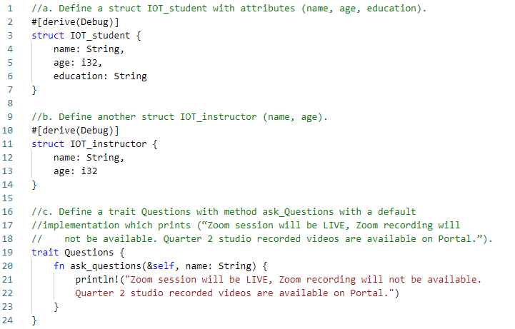

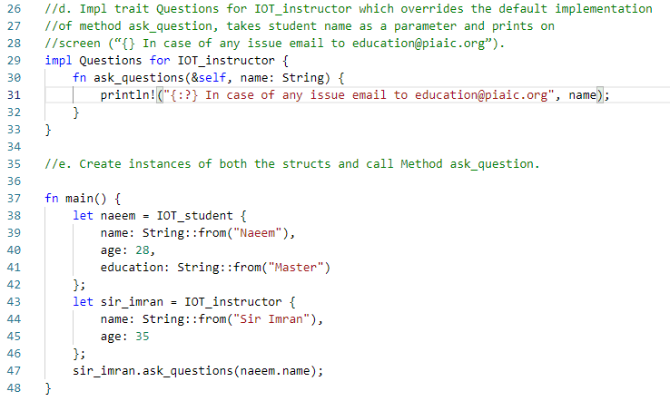

1. Go through the solution of the largest function given at the end of 10.2 in the book and rewrite the solution but this time returning the smallest item instead largest.

